[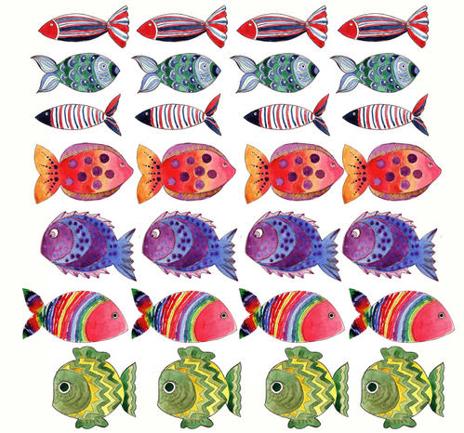](https://www.google.fr/url?sa=i&rct=j&q=&esrc=s&source=images&cd=&cad=rja&uact=8&ved=0ahUKEwjK65Sxso3SAhXE0xQKHaaUBL4QjRwIBw&url=http://dans-mon-bocal.over-blog.com/article-26981434.html&psig=AFQjCNGLUhkCUtJDRF2jKEhp0F61QyuUXg&ust=1487086320123052)